Lesson 5 Demo 6
Remote Triggering of a Parameterized Build

Objective: Trigger parameterized builds in Jenkins remotely
Tools required: Jenkins

Prerequisite: Please ensure you have jenkins installed in order to proceed. In case you don’t have it installed, you can refer to demo 1 of lesson 5 to install jenkins.

Steps to be followed:
- Configure a parameterized build in Jenkins
- Trigger a parameterized build remotely

Step 1: Configure a parameterized build in Jenkins
  - Open the browser and go to Jenkins dashboard by typing localhost:8080 in your browser.
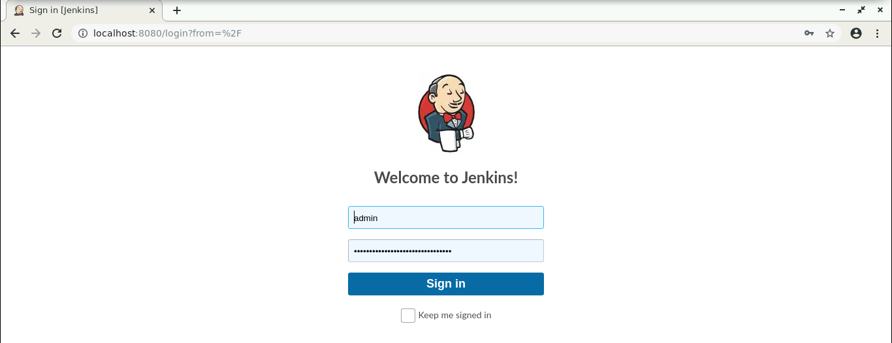

  - Provide the credentials and click on Sign in.

  - Click on Manage Jenkins. From the list of options, choose Manage Plugins.
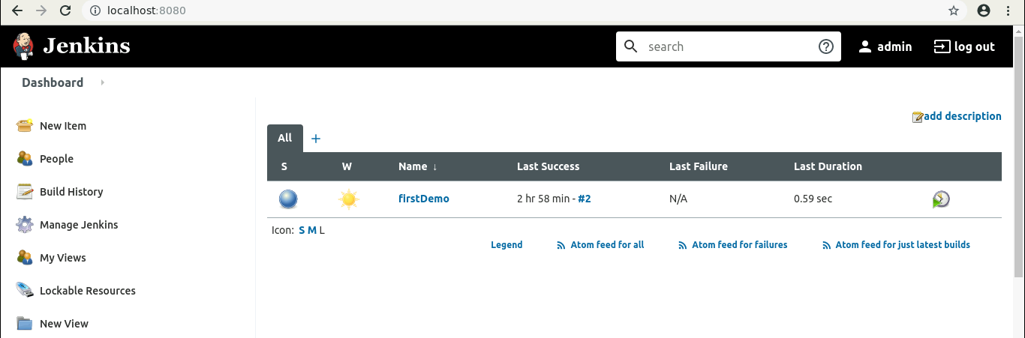

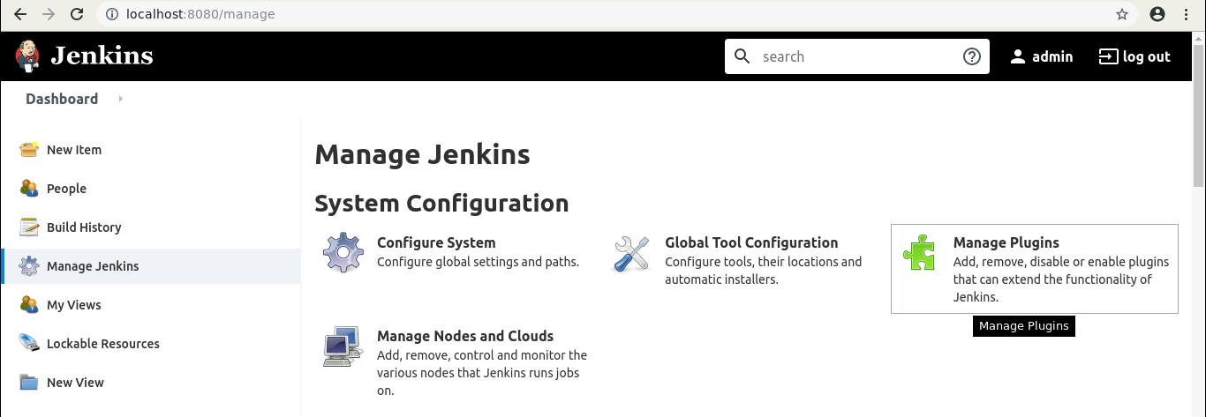

  - Under the Available tab, search for Build with Parameters Plugin. 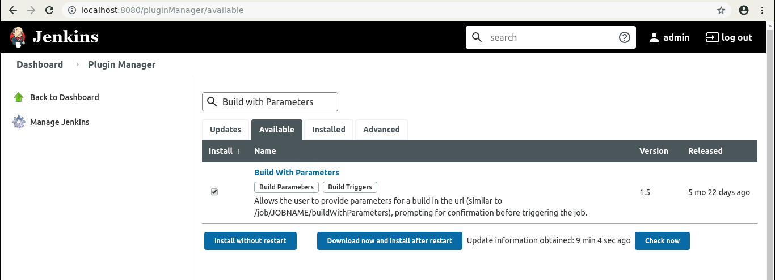

  - Select the checkbox in front of the plugin and click on the Install without restart button.

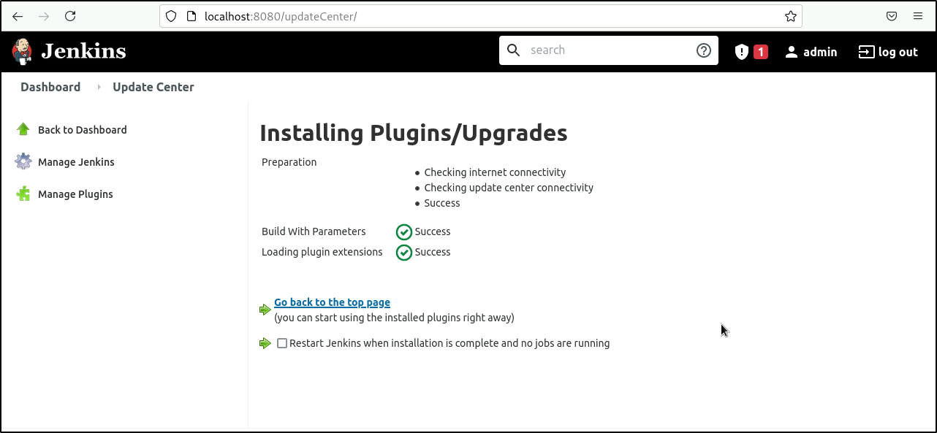

  - Go to the Jenkins Dashboard, click on New Item in the Jenkins dashboard.
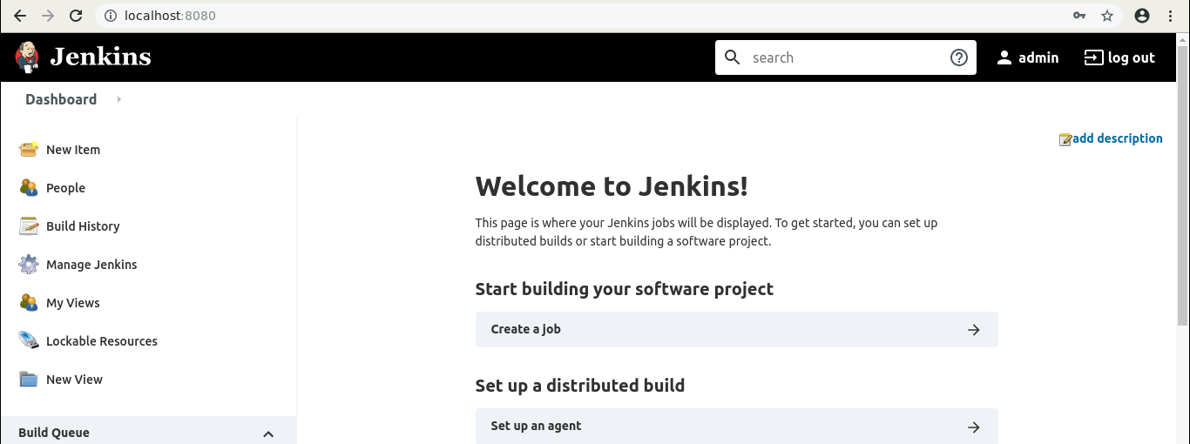

  - Enter a name for your project.
  - Select the Freestyle project as the build job type.
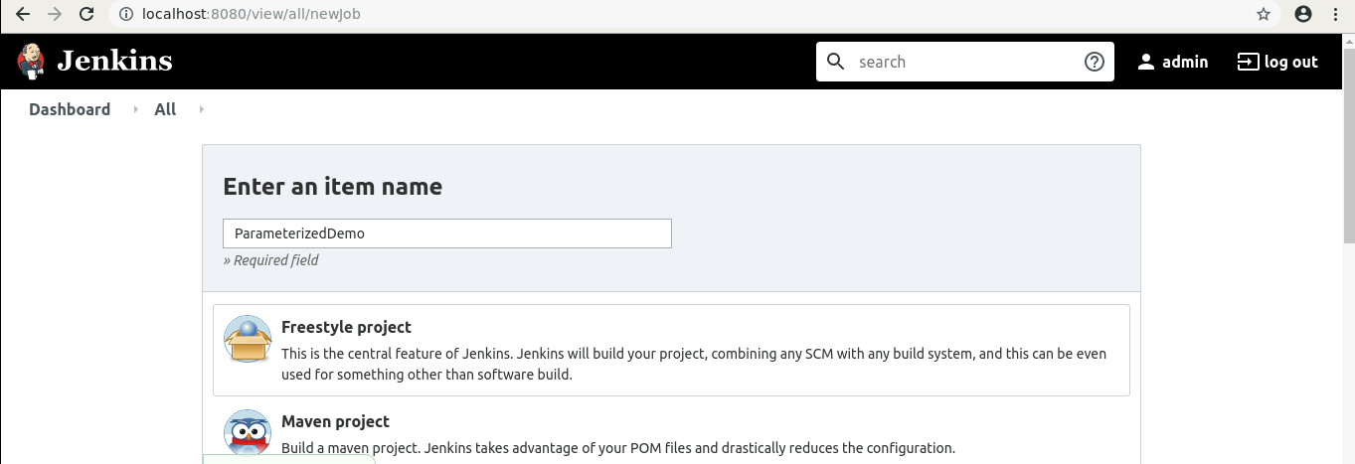

  - Click on OK.
  - On the configuration page, select the checkbox next to text that states, This project is parameterized.
  - Click on the Add parameter button that appears.
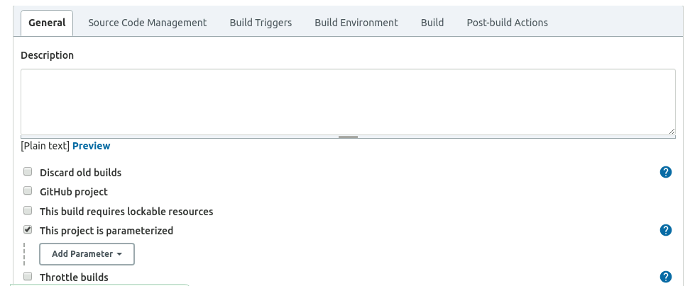

  - From the drop-down menu that appears, select String Parameter.
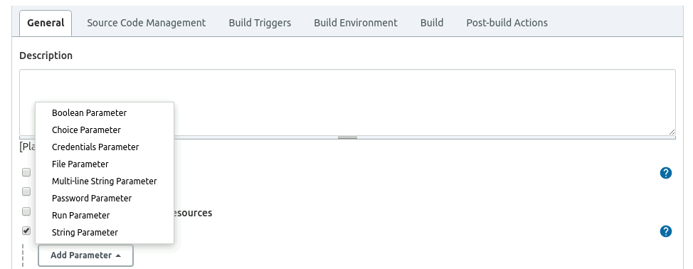

  - Enter the Name of the parameter as my_param, and enter the Default Value. (Ex: hi).
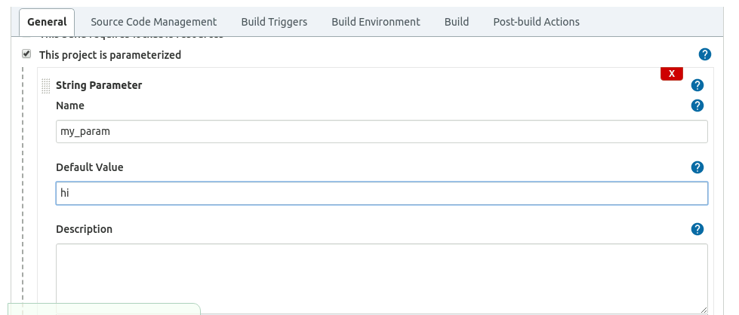

  - Under the Build Triggers section select Trigger builds remotely and type Sam as the token value.

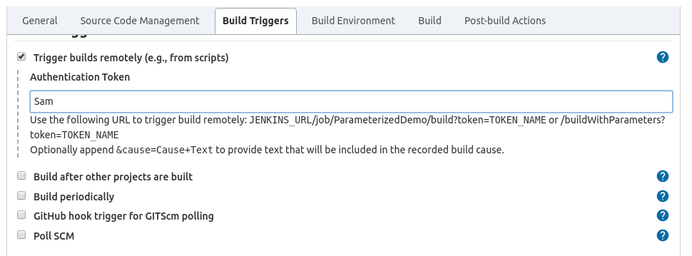

Step 2: Triggering a parameterized build remotely

  - Copy the URL to the job from the project window.
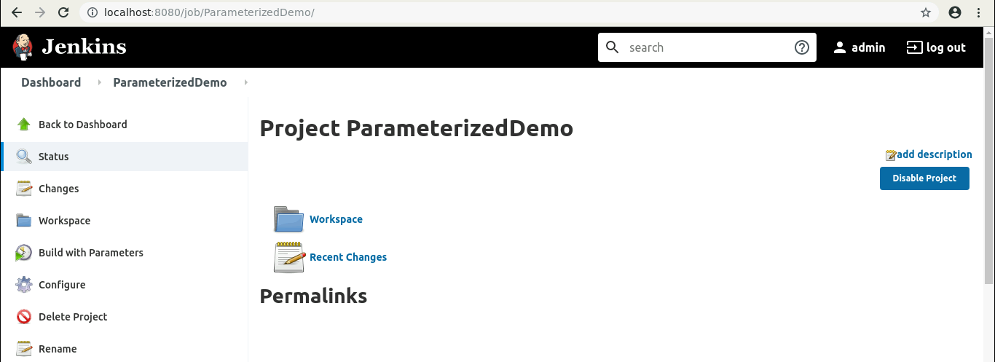

  - Open the terminal.
  - Suffix the parameter and its value to the URL copied in the previous step and send a GET request using Curl.
curl -X GET <YourJenkinsJobUrl>/buildWithParameters?token=Sam
Note: In case you get an authentication error, check your security settings in Manage jenkins > Configure Global Security . It should be configured as shown below:

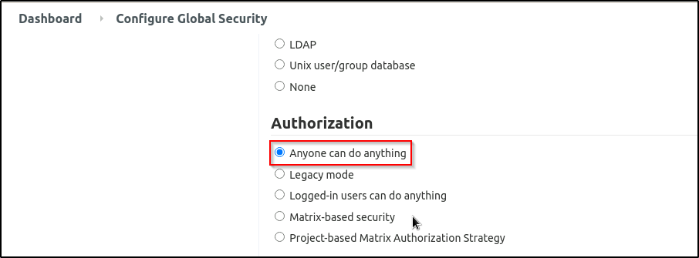

  - Open the job in the Jenkins UI.
  - Click on the Build History to view the build results.
  - Click on the Console Output to view the build logs.
  - The parameter value will be displayed in the console output.
